A document indicating the following: Group Name and Team Members. The theme and ideas of the application and a background to how the theme was arrived at, include your design documentation and testing documentation. Outstanding features of note, Unique Selling Point.

Group Name – Group 10

Members
Brendan Fitzpatrick
Jayne Grant
Cillian McKermitt
Luke Hinton

Background – initial idea.
As a group we discussed which application we would each like to use as individuals, this intial conversation would give each individual a better insight into what we wanted to create as an overall application. We each had ideas on individual programmes e.g. a Programme that would monitor an individuals BMI, a programme that could instruct a user if their resting heart rage meets the recommended heart rate for age and a programme that could give information to a user about their sleep patterns and their BMR. Luckily for the group the individual programmes we wanted to create incorporated health as a main theme.

In today’s application market there is certainly no shortage of health apps, however we reached the conclusion that some of the programmes had a unique selling point. First of all, an application that monitors sleep patterns on a weekly basis is virtually unheard of, however it is an important feature to instruct a user of healthy/unhealthy sleep patterns.
Secondly a heart rate app that instead of just recording heart rates in comparison to previous days and weeks, instructs the user what a healthy heart rate would be for their age group. The app would also incorporate essential programmes, like a BMI and BMR checker that is tailored to the induvial on an extremely versatile and easy to use interface

We therefore came to the conclusion that we could develop an application what encompasses several areas of unique health monitoring, that would come under the application name Ultra Health.

Design process

As a group we discussed in great detail how we would each contribute to the application to keep the process fair and evenly distributed. We decided that we would each take on an individual class, and collectively create a Test application at the end. Luke would take on the responsibility of creating a Main class, with a heart rate sub class. Cillian would take the responsibility of creating the BMR sub class, Jayne would take the responsibility of creating the BMI class and Brendan would take on the responsibility of developing the Sleep Average class. We used the online service Trello to share our initial ideas on the structure and layout. We were each able to create a Trello account very easily and started to share information on each of the sections
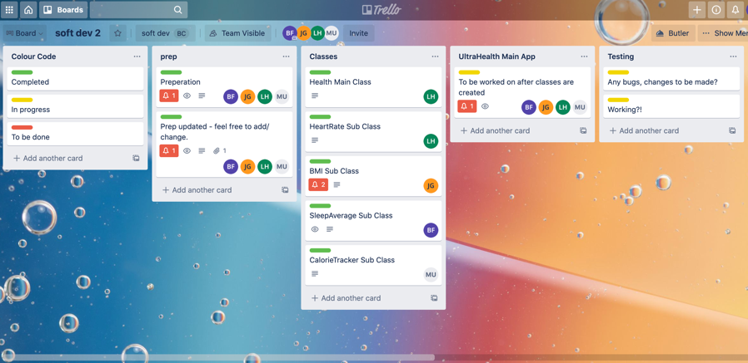
ULTRA HEALTH MAIN DESIGN BOARD.
We used this main board to detail initial processes including prep, Classes, UltraHealth Main App and testing

.
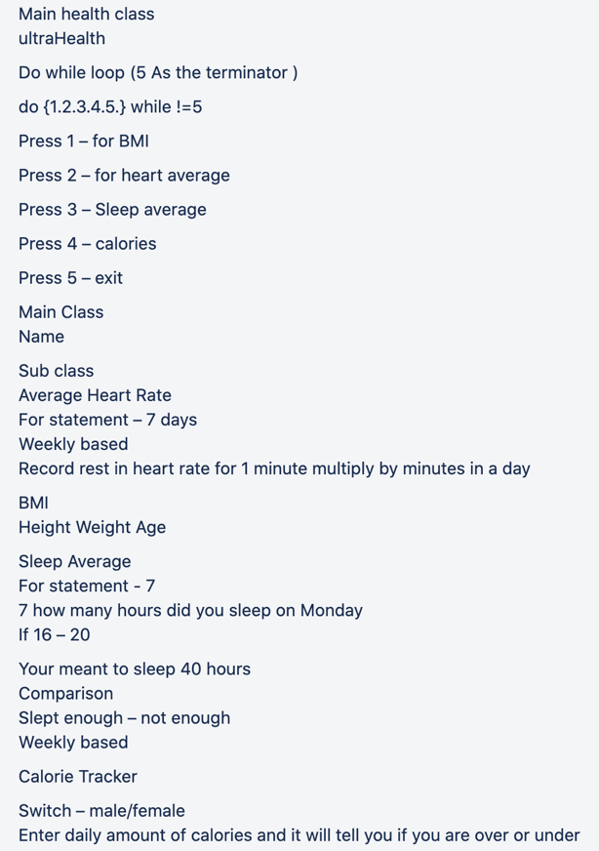
EXAMPLE OF PLAN LAYOUT IN THE PREP HEADER
This initial plan was devised on trello and allowed the group to understand fully the direction and layout of the application
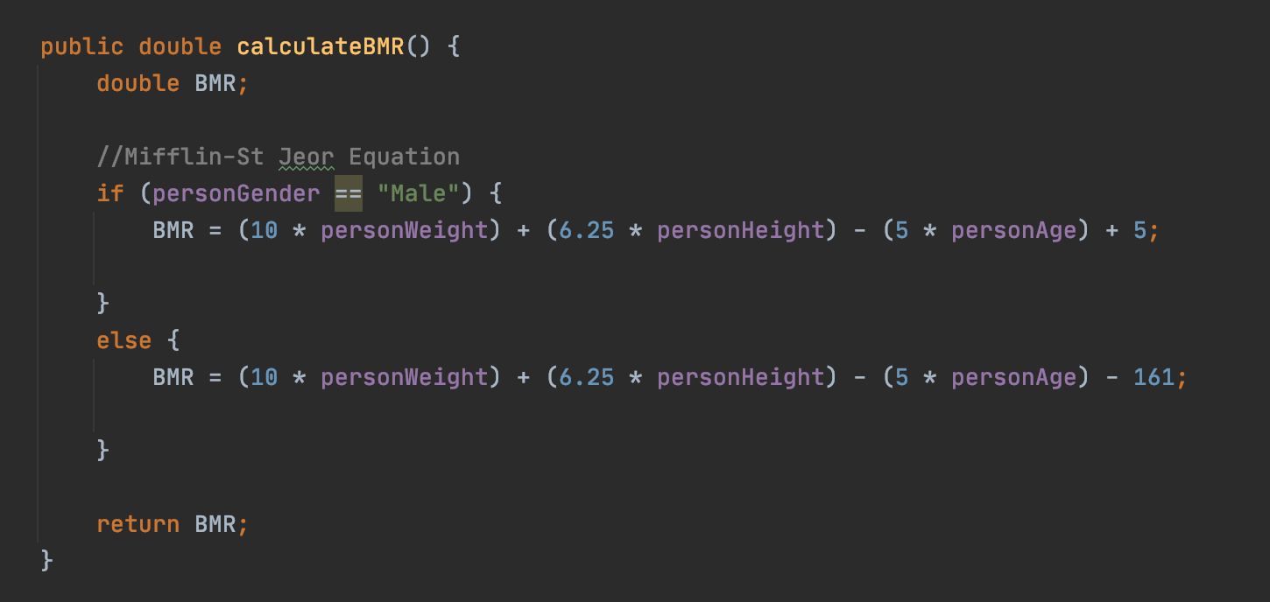

Error on invalid age

An Example of one of the errors we had to fix on the programme, was ensuring that whenever an invalid age is entered that it would no longer prompt the user on how many hours they had slept throughout the week. In the example below you can see that 7+ is the minimum age required, however when 6 is entered the programme still continues. To amend this an if Statement was added to Sleep average programme.
